Date: March 5th, 2025

GTS Architecture Delivery Request - Aegon Red Team Target Infrastructure

The GTS SOC Red Team performs internal and external penetration tests and security assessments against both internal and external Aegon infrastructure and (web) applications. The diagram below depicts the desired target architecture for the Red Team in order to effectively execute these engagements.

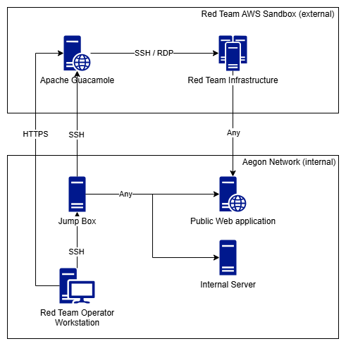
Figure 1 - Desired Red Team target infrastructure. Only the server labeled 'jump box' is a newly introduced resource that requires to be added to internal Aegon infrastructure.

The GTS SOC Red Team identified the following requirements:
- External hosts accessible from the Aegon network to perform penetration tests from;
- Ability to manage external host(s) over SSH from internal workstations;
- Internal (AWS) host to act as a jump box to manage the external hosts;
- Internal host to act as a SOCKS proxy to have a single internal IP address to test from for internal engagements.

- External hosts from the Aegon network to test from
The Red Team AWS Sandbox account currently provides the functionality to maintain our own external resources. The sandbox infrastructure exposes an instance running Apache Guacamole that allows the Red Team to connect to its underlying infrastructure via SSH or RDP from a web browser over HTTPS.

- Ability to manage external hosts over SSH
Outbound SSH traffic from workstation is currently being blocked on the network. The exposed Apache Guacamole host must be able to be managed over SSH from a workstation on the internal network. This can be due to a variety of reasons such as: updating configuration, access management, and troubleshooting.

- Internal host to act as a jump box to manage external hosts
It is preferred to have a host positioned in the internal network to act as a jump box to reach the external facing sandbox host over SSH. This ensures that outbound SSH traffic from workstations remains blocked on the network. The internal host should be added to the regular AWS Red Team account (469155533549) as a compliant Configuration Item. This also ensures that in the event that a firewall rule requires to be added (e.g. avoiding TLS interception) it can be mapped to the internal host instead of individual Red Team operator’s workstations. Access to the internal host should only be possible over SSH for members of the AD Group ‘GTS Red Team’.
- Internal host to act as a SOCKS proxy to have a single internal IP address to test from
When using the internal jump box host as a SOCKS proxy the Red Team can ensure that single IP address is used for internal Red Team activities on the Aegon network. This supports easier tracking, filtering, and whitelisting the IP address when used in internal Red Team engagements.

The above architecture description ensures a high level of security by using the following measures:
- External testing can be performed from managed Aegon assets;
- All internal penetration testing activity originates from a single IP address;
- No additional firewall allow rules have to be configured for outbound network traffic;
- Having a business application / configuration item (red team jump box) registered in the CMDB ensures we can follow the proper process to request exceptions when needed instead of using unfavorable workarounds.
- Access to the AWS Sandbox environment is only possible from the internal Aegon network either with password based authentication (HTTPS) or key based authentication (SSH). This could include periodic entitlement and access log review for the Apache Guacamole instance if required.

